DHA Suffa University
Department of Computer Science
Final Year Project



CapstoneConnect: Facilitating Seamless Interaction between Supervisors and Students in Final Year Projects.
(P-2067)

Software Requirements Specifications
Submitted by
Ayushmann Kukreja (CS201245)
Murtaza Mehdi (CS201211)
Abdul Rehman Khan (CS201250)
Supervisor(s)
Urooj Waheed
Yusra Mansoor

Fall 2023

Document Sign off Sheet

Document Information
Project Title | CapstoneConnect
Project Code | P-2067
Document Name | Software Requirements Specifications
Document Version | 2.0
Document Identifier | P-2067 (SRS)
Document Status | Final
Author(s) | Ayushmann Kukreja  Abdul Rehman Khan  Murtaza Mehdi
Approver(s) | Urooj Waheed
Issue Date | 25/1/2024

Name | Role | Signature | Date
Ayushmann Kukreja | Team Lead |  | 25/1/2024
Murtaza Mehdi | Team Member 2 |  | 25/1/2024
Abdul Rehman Khan | Team Member 3 |  | 25/1/2024
Urooj Waheed | Supervisor |  | 25/1/2024
Yusra Mansoor | Co-Supervisor |  | 25/1/2024
Syed Saad Luqman | Project Coordinator |  | 25/1/2024

Revision History

Date | Version | Description | Author
24/1/2024 | 1.0 | Initial version without proper alignment of text for content verification from supervisor | Ayushmann Kukreja  Abdul Rehman Khan  Murtaza Mehdi
25/1/2024 | 2.0 | Final version with proper alignment | Ayushmann Kukreja  Abdul Rehman Khan  Murtaza Mehdi

Definition of Terms, Acronyms, and Abbreviations

Term | Description
SRS | Software Requirement Specification
FYP | Final Year Project
SQL | Structured Query Language
OS | Operating System
IT | Information Technology
WAN | Wide Area Network
LAN | Local Area Network
OAuth | Open Authorization
API | Application Programming Interface
TCP/IP | Transmission Control Protocol/Internet Protocol
FAQs | Frequently Asked Questions

Table of Contents

1. Introduction 6
1.1 Purpose of Document 6
1.2 Intended Audience 6
2. Overall System Description 7
2.1 Project Background 7
2.2 Problem Statement 7
2.3 Project Scope 8
2.4 Not In Scope 10
2.5 Project Objectives 11
2.6 Stakeholders & Affected Groups 11
2.7 Operating Environment 12
2.8 System Constraints 12
2.9 Assumptions & Dependencies 13
3. External Interface Requirements 14
3.1 Hardware Interfaces 14
3.2 Software Interfaces 14
3.3 Communications Interfaces 15
4. System Functions / Functional Requirements 16
4.1 System Functions 16
4.2 Use Cases 19
4.2.1 List of Actors 19
4.2.2 List of Use Cases 19
4.2.3 Use Case Diagram 20
4.2.4 Description of Use Cases 23
5. Non - Functional Requirements 28
5.1 Performance Requirements 28
5.2 Safety Requirements 28
5.3 Security Requirements 28
5.4 Reliability Requirements 29
5.5 Usability Requirements 29
5.6 Supportability Requirements 29
5.7 User Documentation 30
6. References 31

Introduction

Purpose of Document
The purpose of the SRS document is to provide a detailed and comprehensive description of the functional and non-functional requirements of the CapstoneConnect portal. The SRS document will serve as a contract between the developers and the stakeholders, ensuring a clear and mutual understanding of the scope, features, and specifications of the project. The SRS document will also guide the design, development, testing, and deployment of the CapstoneConnect portal, facilitating a smooth and efficient project execution.

Intended Audience
The intended audiences of the SRS document are:
- The developers who will design, implement, test, and deploy the CapstoneConnect portal based on the requirements specified in the SRS document.
- The stakeholders who will review, approve, and provide feedback on the SRS document and the CapstoneConnect portal.
- The users who will use the CapstoneConnect portal for their capstone projects.

Overall System Description

Project Background
Traditionally, the management of Final Year Projects has been marked by disjointed communication channels, manual tracking methods, and a lack of standardized processes. Students encounter challenges in submitting project proposals, tracking progress, and receiving timely feedback, while supervisors face difficulties in managing multiple projects efficiently. The absence of a centralized platform exacerbates these issues, leading to a suboptimal FYP experience for all stakeholders.
Recognizing these challenges, our project seeks to address the shortcomings in the current FYP management system by introducing "CapstoneConnect," a comprehensive and user-friendly portal dedicated to streamlining the entire FYP process.

Problem Statement
Revamp academic capstone projects with an integrated Capstone Connect portal, addressing inefficiencies in project selection, collaboration, and supervision. Streamlining communication and project management, the portal enhances transparency, making it a central hub for students, faculty, and industry partners to optimize the capstone project experience.

Project Scope

Project scope definition is the process whereby a project is defined and prepared for execution. It helps to decide on whether or not to proceed with the project [1]. The scope of the CapstoneConnect project is carefully defined to encompass the specific functionalities, features, and objectives intended for development and implementation. The projects in scope elements are outlined below:
- User Authentication:
Develop secure and user-friendly registration for students, supervisors, and administrators with robust authentication mechanisms.
- Progress Tracking and Milestone Management:
Design a centralized dashboard for tracking project progress; implement milestone management for FYP lifecycle monitoring.
- Communication Hub:
Establish a seamless communication hub with messaging and notifications between students and supervisors.
- Documentation and Resource Management:
Create a structured system for project document submission and storage; develop tools for resource sharing.
- Collaborative Tools:
Integrate discussion forums and chat features to encourage knowledge sharing among users.
- Evaluation and Grading System:
Implement a comprehensive system for supervisors to assess and provide transparent feedback on project submissions.
- Analytics and Reporting:
Develop analytics for project trends, user engagement, and system performance; provide admin tools for monitoring.
- Security Measures:
Incorporate robust security measures, conduct regular audits, and ensure compliance with data protection regulations.
- Scalability and Integration:
Design for scalability, accommodating user and project growth; ensure seamless integration with institutional systems.
- User Training and Support:
Develop training materials for users and provide ongoing support, including helpdesk services.
- Continuous Improvement and Feedback Loop:
Establish a structured feedback loop for iterative improvements based on user input and evolving needs.

Not In Scope:
While the CapstoneConnect project focuses on specific functionalities and objectives to enhance Final Year Project (FYP) management, there are certain elements that fall outside the defined scope. The out scope elements are outlined below:
- Course Management:
CapstoneConnect does not extend to the management of regular coursework or other academic programs outside the scope of FYPs.
- Grades and Transcripts:
CapstoneConnect is not responsible for managing or recording grades for courses outside the FYP or generating academic transcripts.
- Student Enrollment:
The platform does not handle the enrollment process for courses or academic programs; it specifically focuses on FYP management.
- Research Funding Management:
CapstoneConnect does not manage or track research funding, grants, or financial aspects related to research projects outside the FYP context.

Project Objectives

- Create an intuitive CapstoneConnect portal for seamless navigation.
- Establish a centralized communication hub for transparent interactions.
- Implement robust project management features for efficiency.
- Showcase a repository of past FYPs for inspiration.
- Improve documentation processes for structured submissions.
- Develop a fair system for supervisor allocation and matching.
- Integrate progress tracking tools for real-time monitoring.
- Implement a comprehensive evaluation and grading system.

Stakeholders & Affected Groups
- Students (Primary Stakeholders):-
The primary beneficiaries of the CapstoneConnect project are the students undertaking Final Year Projects (FYPs). They will use the platform for proposal submission, progress tracking, and communication with supervisors.
- Supervisors (Primary stakeholders):-
Faculty members serving as project supervisors play a critical role in guiding and evaluating students throughout the FYP process. They will use CapstoneConnect to monitor progress, provide feedback, and assess project submissions.
- Administrators (Key stakeholders):-
Institutional administrators oversee the overall academic processes and ensure the successful integration of CapstoneConnect into existing systems.

2.7 Operating Environment
The CapstoneConnect portal will operate as a web-based application that can be accessed through any standard web browser, such as Microsoft Edge, Google Chrome, Mozilla Firefox, or Safari. The portal will be hosted on a cloud server, such as Microsoft Azure or Amazon Web Services, and will use a relational database management system, such as MySQL or PostgreSQL, to store and retrieve data.

System Constraints
System constraints for CapstoneConnect:
1. Compatibility: Ensure compatibility across browsers, OS, and devices for a consistent user interface.
2. Security: Prioritize data and communication security, preventing unauthorized access or modification.
3. Performance: Maintain fast and reliable functionality, handling high traffic without compromising user experience.
4. Scalability: Accommodate user and data growth, adjusting system resources accordingly.
5. Maintainability: Ensure ease of updates, modifications, and debugging while adhering to coding standards.

Assumptions & Dependencies
Assumptions:
- User Engagement: Users will actively engage with training and documentation to familiarize themselves with CapstoneConnect for effective implementation.
- Institutional Support: Strong institutional support, including administrator backing and commitment to system integration, is assumed for successful deployment.
- Data Accuracy: Users will provide accurate information during proposal submission and project tracking for reliable progress tracking within CapstoneConnect.
- Technical Infrastructure: The existing technical infrastructure, including network capabilities and server capacities, is assumed to be sufficient for CapstoneConnect's deployment.
- User Feedback Incorporation: Users will actively provide constructive feedback on the CapstoneConnect platform for continuous improvement.
Dependencies:
- IT Department Collaboration: Successful collaboration with the IT department is crucial for development, deployment, and technical support of CapstoneConnect.
- Third-Party Integration: Integration with existing institutional systems depends on cooperation from third-party vendors and service providers.
- User Training Sessions: User training sessions depend on the availability and participation of students, supervisors, and administrators.
- Data Protection Compliance: Compliance with data protection and privacy regulations is a prerequisite for CapstoneConnect's deployment.
- External Collaboration Opportunities: Collaboration opportunities with external stakeholders depend on their willingness and availability.

External Interface Requirements

Hardware Interfaces
As the application is designed to operate over the internet, all necessary hardware for establishing internet connectivity will serve as the system's hardware interfaces. Examples of such interfaces include modems, WAN–LAN connections, and Ethernet cross-cables.

Software Interfaces

- Database Management System (DBMS):
Name of Application: SQL Server
External Owner: Database Administrator
Interface Details: Interaction involves SQL queries and data retrieval methods. The
database schema and connection details will need to be coordinated with the Database Administrator.
- Authentication Service:
Name of Application: OAuth 2.0
External Owner: Identity Provider
Interface Details: Integration involves OAuth 2.0 protocols for secure user authentication. Coordination with the Identity Provider is needed for API keys, client IDs, and secret configurations.

- Email Service:
Name of Application: SendGrid
External Owner: Email Service Provider
Interface Details: The FYP portal interfaces with SendGrid for sending email notifications. Coordination involves API key setup, email templates, and delivery configurations with the Email Service Provider.

Communications Interfaces

Describe communications interfaces to other systems or devices, such as local area networks for the intranet communication will be through TCP/IP protocol suite.

.

System Functions / Functional Requirements

System Functions

Function Category | Meaning
Evident | Should perform, and user should be cognizant that it is performed.
Hidden | Should perform, but not be visible to users. This is true of many underlying technical services, such as save information in a persistent storage mechanism. Hidden functions are often missed during the requirements gathering process.

Ref # | Functions | Category | Attribute | Details & Boundary Constraints
R1 | Display a list of pervious FYPs | Evident | Information about previous FYPs. | Users will be able to see a repository of previous projects. Details of what is to be shown depends on the admin of the portal.
R2 | Facilitate communication between users and supervisors | Evident | Communication platform. | A way for students and supervisors to communicate.  Students can approach supervisors with a request to be supervised by them. If the supervisor accepts the request they can chat with each other from that point on.
R3 | Improve documentation processes by providing an organized platform | Evident | Documentation processes | Improving the documentation process by providing a framework to document your tasks. The portal will keep a record of every entry
R4 | Integrate progress tracking tools to enable real-time monitoring of project milestones | Evident | Progress tracking tools | Improving the progress tracking by the use of a progress tracking tool.  Constraint: An external project tracking tool will be integrated that will require subscription.
R5 | Implement a comprehensive evaluation and grading system | Evident | Grading system | Supervisors will be able to grade students on the base of their work.
R6 | Display a list of available Supervisors | Evident | Available Supervisors | Students will be able to view the lists of supervisors available for FYP.

System Attributes/ Nonfunctional Requirements

Attribute | Details and Boundary Constraints | Category
Intuitive and user-friendly interface | None specified. | Mandatory
High system reliability to ensure minimal downtime. | None specified. | Mandatory
Robust security measures to protect user data and prevent unauthorized access. | Compliance with data protection and privacy regulations. | Mandatory
High system availability to ensure users can access the system when needed. | None specified | Mandatory
Integration of a user feedback mechanism for continuous improvement. | None specified | Optional
Compatibility with different web browsers, operating systems, and devices. | None specified | Mandatory

Use Cases

List of Actors
1. Student:
Enrolled FYP course user. Can browse, select, and submit proposals, communicate with supervisors, upload documents, track progress, and receive feedback.
2. Supervisor:
Faculty or industry user overseeing projects. Can view, approve/reject proposals, communicate with students, monitor progress, and evaluate project submissions.
3. Administrator:
Staff or coordinator managing FYP course and portal. Can create/edit/delete projects, assign/match supervisors, manage user profiles, generate reports, and configure portal settings.

List of Use Cases

- View Supervisors and sends request:
Students view supervisors available for FYP and sends request for supervision for FYP.
- Previous Projects Repository:
Students and supervisor view previous FYPs with titles, descriptions, supervisors, and status.
- Track FYP Progress:
Students and Supervisors track FYP progress, upload documents (literature review, design, code, etc.).

- Evaluate and Grade Project:
Supervisor evaluates and grades FYP submissions using predefined criteria.

- Communication:
Users (students/supervisors) communicate through messages related to FYP

Use Case Diagram

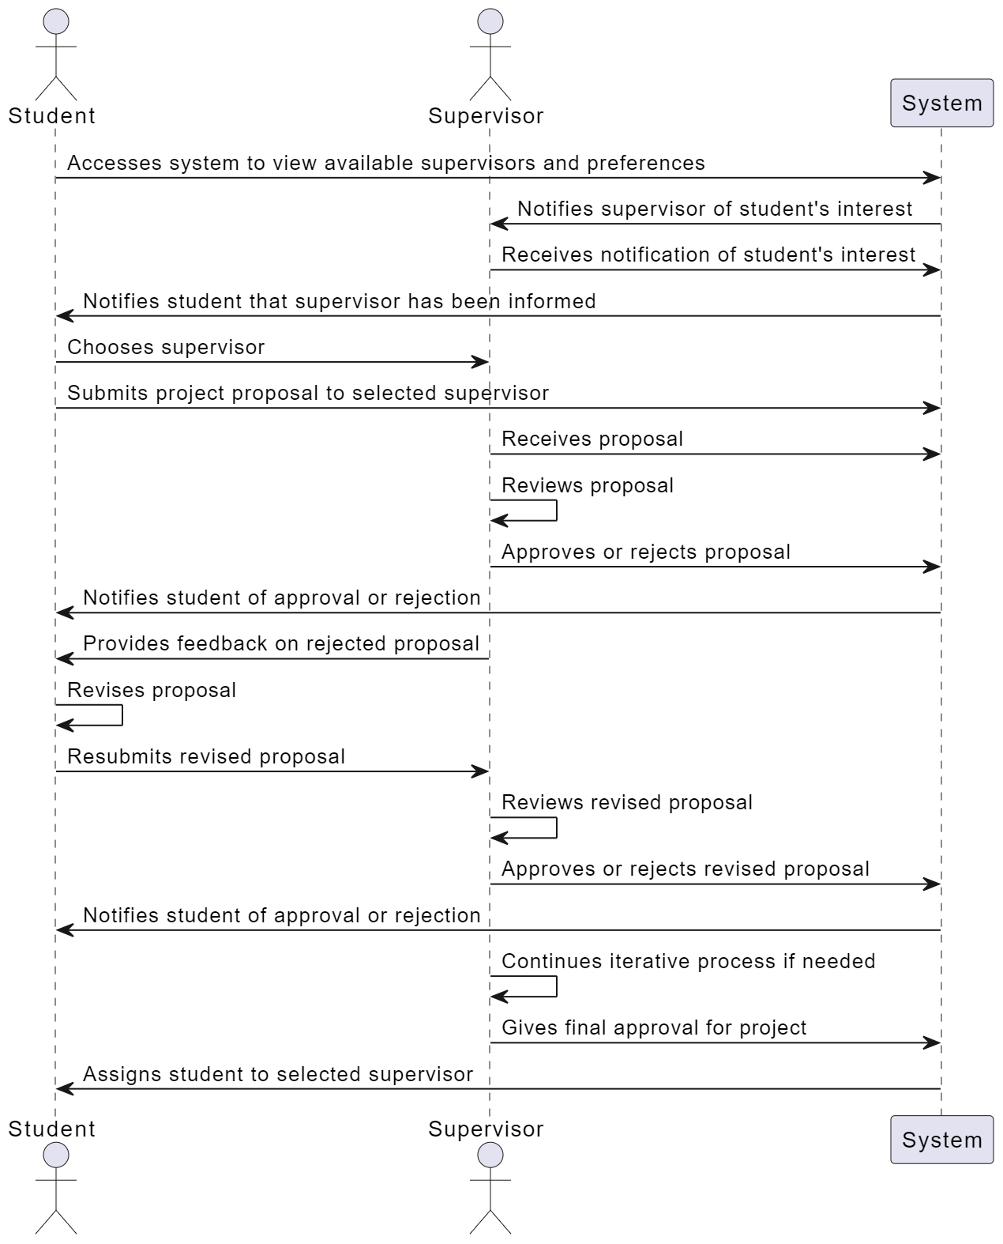
Figure 1: Use Case 1: View Supervisors

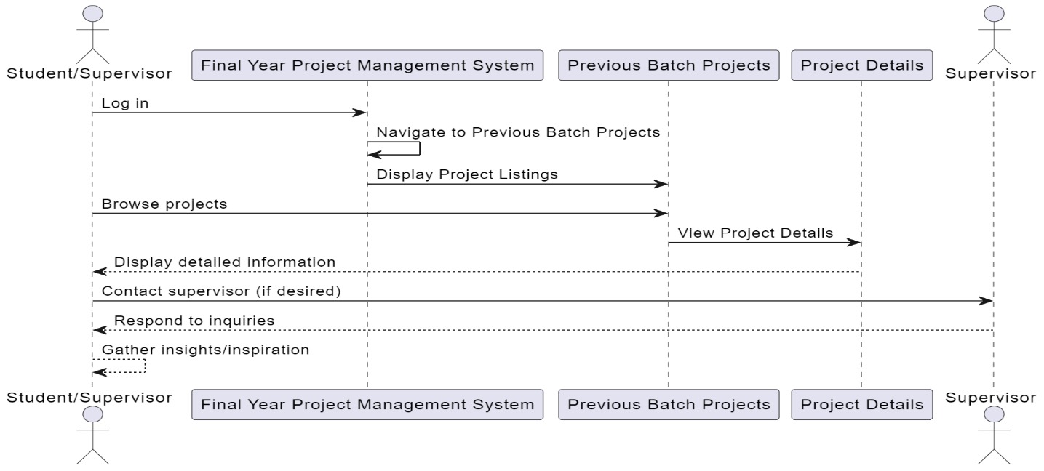
Figure 2: Use Case 2: Previous Projects Repository

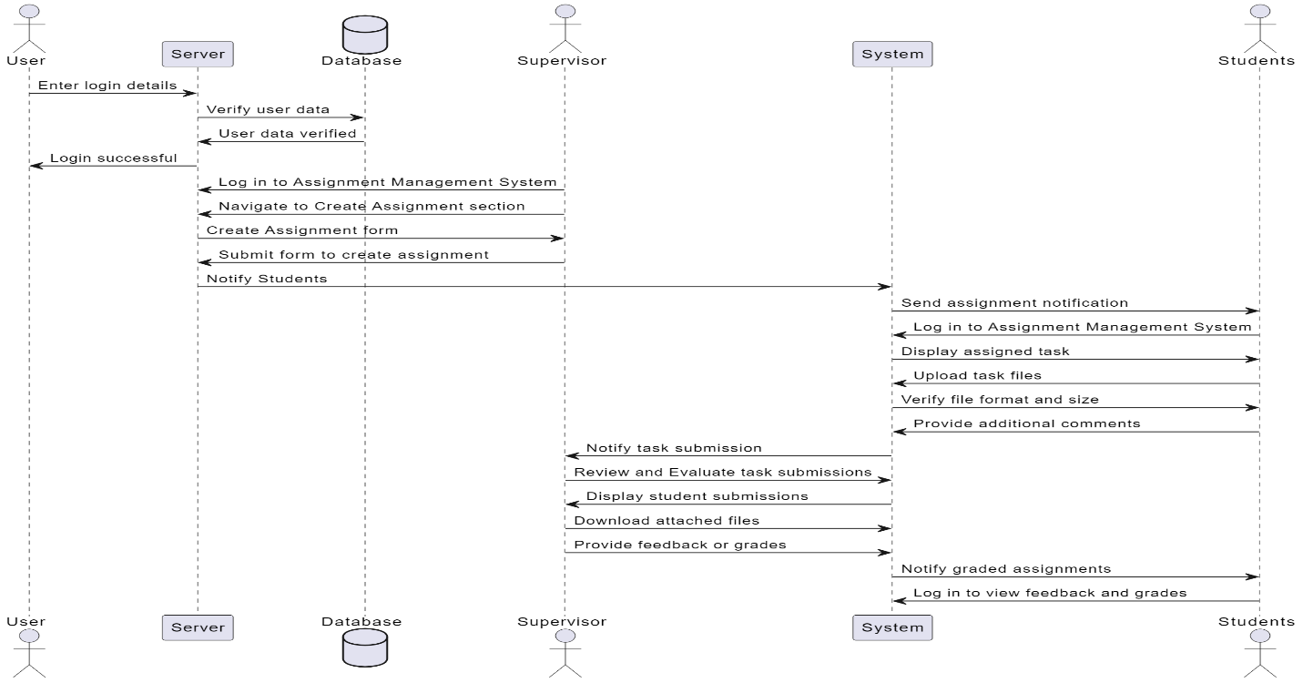
Figure 3: Use Case 3&4: Track and Document Progress, Evaluate and Grade Project:

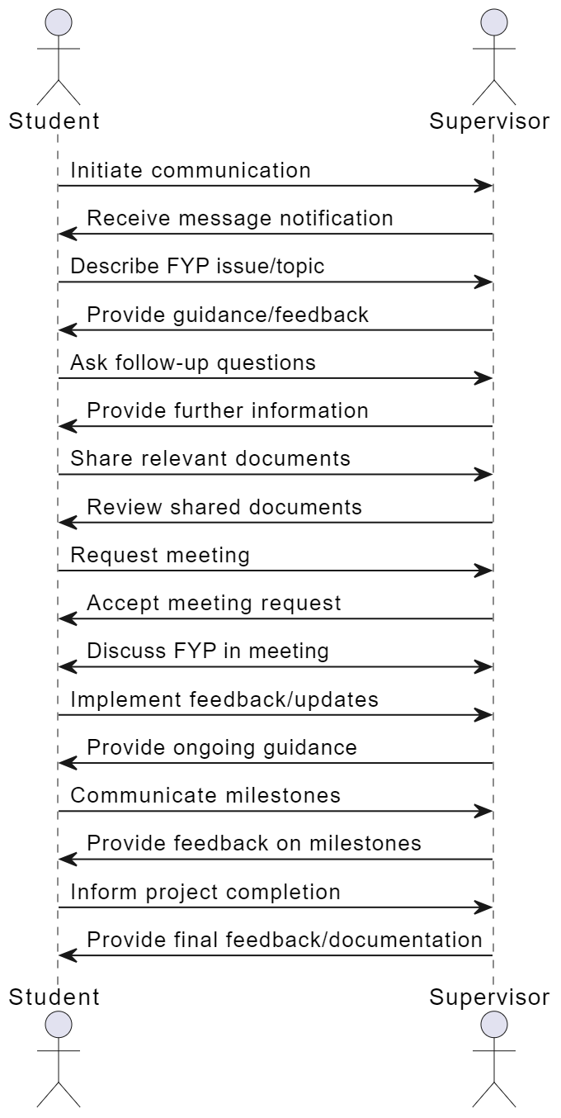
Figure 4: Use Case 5: Communication

Description of Use Cases

Section: Main
Name: |  | View Supervisors and sends request
Actors: |  | Students and Supervisors
Purpose: |  | Student views available supervisors for FYP on the portal and approaches supervisors
Description: |  | A student accesses the portal to view available supervisors and their preferences.
Cross References: |  | Functions: R6  Use Cases: Available Supervisors will be displayed
Pre-Conditions |  | User must be logged in.
Successful Post-Conditions |  | Users can view available supervisors on the portal and choose their supervisor.
Failure Post-Conditions |  | Users cannot access or view available supervisor.
Typical Course of Events
Actor Action |  |  | System Response
1 | The use case begins when a user logs into the FYP portal. |  | Users are validated and allowed to use the portal.
2 | Students initiate a call to view available supervisor and send request to supervisor with their idea |  | The system displays a list of available supervisor
3 | Supervisors provide response (approval or rejection) |  | The system notifies student about supervisor’s decision

Section: Main
Name: |  | Previous Projects Repository
Actors: |  | Students, Supervisors
Purpose: |  | View previous projects on the portal.
Description: |  | A student accesses the portal to browse available FYPs. The system displays FYP details, including titles, descriptions, assigned supervisors, and project status. Students can take an idea of how these projects were developed
Cross References: |  | Functions: R1  Use Cases: Project repository will be displayed
Pre-Conditions |  | User must be logged in.
Successful Post-Conditions |  | Users can view information about previous FYPs according to the admin's specifications.
Failure Post-Conditions |  | Users cannot access or view information about previous FYPs.
Typical Course of Events
Actor Action |  |  | System Response
1 | The use case begins when a user logs into the FYP portal. |  | Users are validated and allowed to use the portal.
2 | Users initiate a call to the projects repository section. |  | The system displays a list of previous FYPs, presenting details based on admin configurations

Section: Main
Name: |  | Track FYP Progress
Actors: |  | Students, Supervisors
Purpose: |  | Keep track of FYP
Description: |  | A student regularly updates their task or assignment which makes it easy for both student and supervisor to keep track of FYP progress.
Cross References: |  | Functions: R3&R4  Use Cases: Track FYP Progress
Pre-Conditions |  | Student must have gotten approval for their project proposal
Successful Post-Conditions |  | Students and supervisors can keep track of FYP progress
Failure Post-Conditions |  | Students and supervisors cannot keep track of FYP progress
Typical Course of Events
Actor Action |  |  | System Response
1 | The use case begins when a user logs into the FYP portal. |  | Users are validated and allowed to use the portal.
2 | Supervisors upload a task for student |  | The system notifies students that the supervisor has upload a task.
3 | Student works on the task and updates the status of task |  | The system notifies supervisor which task is done and request for feedback and grading

Section: Main
Name: |  | Evaluate and Grade Project
Actors: |  | Supervisors
Purpose: |  | Supervisors regularly grade and evaluate tasks.
Description: |  | A supervisors provide regular updates and grade students submission.
Cross References: |  | Functions: R5  Use Cases: Evaluate and Grade Project
Pre-Conditions |  | Supervisor must be logged In and Student must have updated their submissions.
Successful Post-Conditions |  | Student gets notification about feedback from supervisor.
Failure Post-Conditions |  | Student don’t get any feedback from supervisors.
Typical Course of Events
Actor Action |  |  | System Response
1 | The use case begins when a supervisor logs into the FYP portal. |  | Users are validated and allowed to use the portal.
2 | Supervisor initiate a call to the view a submissions of student. |  | The system displays submission of student

Section: Main
Name: |  | Communication
Actors: |  | Supervisors and Students
Purpose: |  | Students and Supervisors communication
Description: |  | The CapstoneConnect portal bridges the gap between student and supervisor by providing a platform for communication.
Cross References: |  | Functions: R2  Use Cases: Communication
Pre-Conditions |  | Supervisor and Students are available for communication
Successful Post-Conditions |  | Student and Supervisor communicate and deliver their message through this platform.
Failure Post-Conditions |  | Both actors aren’t able to able to deliver their message.
Typical Course of Events
Actor Action |  |  | System Response
1 | The use case begins when user logs into the FYP portal. |  | Users are validated and allowed to use the portal.
2 | Student sends a message to supervisor related to FYP. |  | The system sends a notification about message to supervisor
3 | Supervisors replies back to student regarding their query |  | The system sends a response back to student.

Non - Functional Requirements

Performance Requirements
The CapstoneConnect portal should provide fast and reliable functionality, and should handle high traffic and concurrent requests without compromising the user experience or the system stability. The portal should also have a low response time and a high throughput for all the system functions.

Safety Requirements
The CapstoneConnect portal should ensure the safety and integrity of the user data and the communication between the users and the server, and should prevent data loss, corruption, or leakage. The portal should also have a backup and recovery mechanism to restore the system in case of a failure or a disaster.

Security Requirements
The CapstoneConnect portal should ensure the security and privacy of the user data and the communication between the users and the server, and should prevent unauthorized access, modification, or deletion of the data. The portal should implement security measures, such as encryption, authentication, authorization, and auditing.

Reliability Requirements
The CapstoneConnect portal should ensure the reliability and availability of the system functions and the user data, and should minimize the occurrence and impact of errors, faults, or failures. The portal should also have a high mean time between failures (MTBF) and a low mean time to repair (MTTR).

Usability Requirements
The CapstoneConnect portal should ensure the usability and accessibility of the system functions and the user interface, and should meet the user expectations and satisfaction. The portal should also follow the usability principles and best practices, such as simplicity, consistency, feedback, and error prevention. The portal should also support different languages, cultures, and preferences of the users.

Supportability Requirements
The CapstoneConnect portal should ensure the supportability and maintainability of the system functions and the user data, and should facilitate the update, modification, and debugging of the system. The portal should also follow the coding standards and best practices, such as modularity, readability, and documentation. The portal should also provide technical support and customer service to the users.

User Documentation

The CapstoneConnect portal should provide user documentation that describes the system functions, features, and specifications, and guides the users on how to use the system effectively and efficiently. The user documentation should also include tutorials, FAQs, and troubleshooting tips. The user documentation should be clear, concise, and accurate, and should be updated regularly.

References

[1] | A. A. A. Mohammed K. Fageha, "Science Direct," 29 March 2013. [Online]. Available: https://www.sciencedirect.com/science/article/pii/S1877042813004679#bbib0005.

